Lab 13
Configuring Security Settings

Exercise 13.1 | Installing Internet Information Server
Overview | Because this is only a test deployment, you will be using a Windows 7 computer to function as the web server. In Exercise 13.1, you install Internet Information Services on your workstation and configure it to host two websites.
Completion time | 15 minutes

Question 1 | What URL would you use in your computer’s browser to test the functionality of the intranet website you just created?

18. Take a screen shot of the Internet Information Services (IIS) Manager console, showing the new site you created, by pressing Alt+Prt Scr, and then paste the resulting image into the Lab13_worksheet file in the page provided by pressing Ctrl+V.
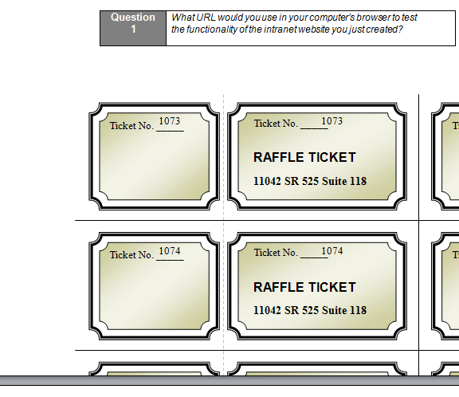
Exercise 13.2 | Testing IIS Connectivity
Overview | In Exercise 13.2, you test the functionality of the web server you just installed.
Completion time | 20 minutes

Question 2 | What is the result, and what does the result indicate?
Question 3 | What is the result, and what does it indicate?
Question 4 | What is the result?
Question 5 | What is the result?
Question 6 | List three possible reasons why you might be unable to connect to your computer’s web server using a browser on another computer.
Question 7 | What are the results, and what do the results indicate?
Question 8 | What other test could you perform to prove that it was your computer’s firewall that was blocking the connection and not the firewall on the computer you are using as a client?
Question 9 | Why is it necessary to clear the cache before you retest the web server connections?
Question 10 | Why can you not simply leave Windows Firewall turned off when you deploy an actual web server?

Exercise 13.3 | Allowing a Program Through the Firewall
Overview | Windows Firewall is preventing clients from connecting to the web server. In Exercise 13.3, to enable client access, you will use the Windows Firewall control panel to allow access to the web server.
Completion time | 10 minutes

Question 11 | Why are you now able to connect to the website from the client?
Question 12 | Why are you unable to connect to the intranet site from the client?

Exercise 13.4 | Creating Windows Firewall Rules
Overview | The port you opened in Exercise 13.3 enables clients to access the default web site hosted by your web server, but not the intranet web site. In this exercise, you use the Windows Firewall With Advanced Security console to create rules that will enable clients to access both web sites.
Completion time | 15 minutes

Question 13 | Why are there two separate rules for the World Wide Web Services?
Question 14 | How do the properties of the two rules differ?
Question 15 | How would the opening of the port you performed in Exercise 13.3 affect the World Wide Web Services (HTTP Traffic-In) rules you just examined?
Question 16 | What happens to the list of rules?
Question 17 | How would the rule creation procedure you just performed differ if you wanted to restrict client access to the intranet website to computers on the local network only?

14. Take a screen shot of the Properties sheet for the new rule by pressing Alt+Prt Scr, and then paste the resulting image into the Lab13_worksheet file in the page provided by pressing Ctrl+V.

Question 18 | What are the results, and why are they different from the results you experienced with the program exception?

